Quick overview

npm install redux react-redux redux-thunk redux-devtools-extension
1- First inside app.js
import { applyMiddleware, createStore } from 'redux';

import { Provider } from 'react-redux';

import rootReducer from './rootReducer';
import thunk from 'redux-thunk';
import { composeWithDevTools } from 'redux-devtools-extension';

2 – create store with middlewares inside app.js
const middleware = [logger,thunk];

const store = createStore(
rootReducer,
{},
composeWithDevTools(applyMiddleware(...middleware)),
);

3 – Make store available inside other components ( i.e wrap your app inside provider tag)
<Provider store={store}>

4 – Make a rootreducer file , first keep it blank

5 – Create folders based on functionality , eg toggle folder

6 – Inside toggle folder along with toggle.jsx , create actions.js and reducer.js file

7 – Inside actions.js , create all actions of that component functionality along with action name stored inside a constant
export const TOGGLE_MESSAGE = 'TOGGLE_MESSAGE';

export function toggleMessage() {
return {
type: 'TOGGLE_MESSAGE',
}
}

8 – Inside reducer.js
first import all const names defined in actions.js of that component
import { TOGGLE_MESSAGE } from './actions';

then create a initial state
const initialState = {
messageVisibility: false,
};

then create a reducer which is a function
export default function (state = initialState, action) {
const { type } = action;

switch (type) {
case TOGGLE_MESSAGE:
return {
...state,
messageVisibility: !state.messageVisibility
};
default:
return state;
}
}

9 – Inside Toggle.jsx lets use this actions and reducers
first import connect to connect it to store
import { connect } from 'react-redux';
import action here

Note that we dont need to import reducer as all reducers are combined in combine reducer in root of file and is running inside store in app.js

then
import { bindActionCreators } from 'redux';

then pull out state which you want inside this component
const mapStateToProps = (state) => ({
messageVisibility: state.toggle.messageVisibility,
})

here state.toggle.messageVisibility, comes from rootReducer

then bind dispatch to actions functions created in action creator i.e actions.js
const mapDispatchToProps = dispatch => bindActionCreators({
toggleMessage: toggleMessage,
getMovies: getMovies,
}, dispatch);

then
export default connect(mapStateToProps, mapDispatchToProps)(Toggle);

finally use this actions and reducer
const Toggle = ({ messageVisibility, toggleMessage, getMovies }) => {
return (
<div>
{messageVisibility &&
<p>Toggle Button Worked</p>
}

<button onClick={toggleMessage}>Toggle Me</button>

<button onClick={getMovies}>Load Movies</button>

</div>
);
};

10 – Inside root reducer , combine all reducers
import { combineReducers } from 'redux';

import toggle from './toggle/reducer';
import movies from './movies/reducer';

const rootReducer = combineReducers({
toggle,
movies,
});

export default rootReducer;

Basics
1)It is quite difficult to pass state to child components and if we have tree then passing state from top most component to last component is very difficult. So we need state management like redux where we create a state in single location and all other components access state from that location.

2)Store in redux
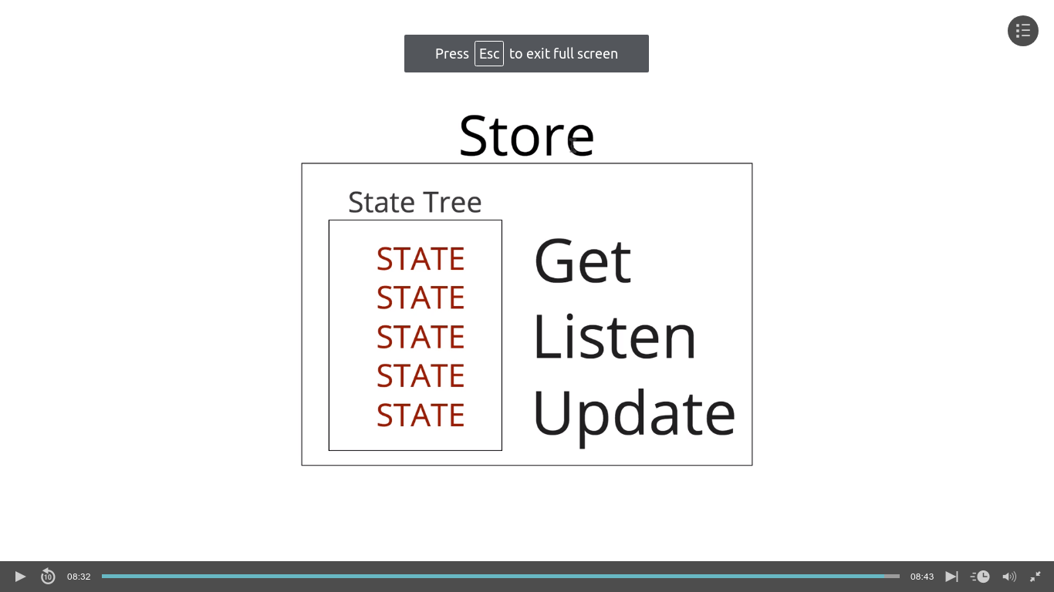
it has state tree, method to get ,liisten and update state

Just Redux ( Without React-redux )

1 - first create a basic react app using create-react-app

2 – then
npm install redux

3 – in app.js
import { createStore } from 'redux';

4 – in app.js below export

const hello = () => {
return({welcome:'hello'});
};

const store = createStore(hello);
console.log(store.getState());
here

const hello = () => {
return({welcome:'hello'});
};
is a reducer

const store = createStore(hello);
Store takes in a reducer
reducer is just a function which returns something( Generally State )
store.getState() is a method to get state inside that store

5 – Another large example

// First create default state
const defaultState = {
welcome: 'Hi',
otherState: 'Some Stuff'
};

// create Reducer , here while returning use spread operator to return previous state otherwise it will be not there in state
const greeting = (state = defaultState, action) => {
switch (action.type) {
case 'GREET_ME':
return { ...state, welcome: 'Hello Akash' };
case 'GREET_WORLD':
return { ...state, welcome: 'Hello WORLD' };
default:
return state;
}
};

// Create store
const store = createStore(greeting);

console.log(store.getState());

// Dispatch action which just an object
store.dispatch({
type: 'GREET_ME'
});

console.log(store.getState());

Redux with React
1 – First install
npm install redux react-redux

2 -
import { Provider } from 'react-redux';

3 – Then enclose your app.js or any main component which loads first inside Provider
Provider takes 2 things one is store={} and other is children
Provider makes redux available to our entire applicn via ‘Connect’
const App = () => (
<Provider store={}>
<Router>
<div className="App">
<header className="App-header">
<Link to="/" style={{ textDecoration: 'none' }}>
<h1 className="logo">Latest Movies</h1>
</Link>
</header>
<Switch>
<Route exact path="/" component={MoviesList} />
<Route path="/:id" component={MovieDetail} />
</Switch>
</div>
</Router>
</Provider>
);

4 – Now we need to pass store to our provider
import { createStrore } from 'redux';

const hello = () => "hello";
const store = createStore(hello);

const App = () => (
<Provider store={store}>
<Router>
........... rest of code

5 – Create a new file inside src called rootReducer.js , it contains and combine all reducers in your project

6 – First we need reducer so inside src create file reducer.js
const initialState = {
messageVisibility: false,
};

export default function (state = initialState, action) {
const { type } = action;

switch (type) {
case 'TOGGLE_MESSAGE':
return state;
default:
return state;
}
}

7 – Now inside rootReducer import that reducer and combine it ( Single reducer actually do not need combine but use it for future scope ) -

import { combineReducers } from 'redux';

import message from './reducer';

const rootReducer = combineReducers({
message,
});

export default rootReducer;

8 – Inside app.js edit

import rootReducer from './rootReducer';

const store = createStore(rootReducer);

9 – Installing redux -dev tools
first download chrome extension
then
npm install redux-devtools-extension
then
import { composeWithDevTools } from 'redux-devtools-extension';
then inside store
const store = createStore(
rootReducer,
{},
composeWithDevTools(),
);

10 – Create a component called Toggle
inside toggle create a simple button
<button>Toggle Me</button>

inside app.js import that button and place it in jsx

11 – inside toggle , import connect
import { connect } from './react-redux';

replace export default to -
export default connect()(Toggle);

then pluck out those part of state which you need and pass it in export

const mapStateToProps = (state) => ({
messageVisibility: state.message.messageVisibility,
})

export default connect(mapStateToProps)(Toggle);

now messageVisibility is available as props, we can use it like
const Toggle = ({ messageVisibility }) => {
return (
<div>
{messageVisibility &&
<p>Toggle Button Worked</p>
}

<button>Toggle Me</button>
</div>
);
};

12) Now we need to make action to actually make our toggle work

notice that ‘connect’ makes dispatch method available as a prop in here when we use connect
const mapStateToProps = (state) => ({
messageVisibility: state.message.messageVisibility,
})

now we need to use dispatch method

const Toggle = ({ messageVisibility, dispatch }) => {
return (
<div>
{messageVisibility &&
<p>Toggle Button Worked</p>
}

<button onClick={() => dispatch({
type: 'TOGGLE_MESSAGE',
})}>Toggle Me</button>
</div>
);
};

13) Action Creator
In below line of code
<button onClick={() => dispatch({
type: 'TOGGLE_MESSAGE',
})}>Toggle Me</button>

we are dispatching action, but suppose we have to reuse that action , in this case we use action creators which is simply a file that contains some functions which returns object

eg -
create a file named actions inside src
export function toggleMessage() {
return {
type: 'TOGGLE_MESSAGE',
}
}

here we are simply returning an object

so when dispatching action -
First import that file
then
<button onClick={() => dispatch(toggleMessage())}>Toggle Me</button>

Note that to execute that function immediately because dispatch needs object and passing only function name will not work

14) Bind action creators
Now when we dispatch the action we use below syntax
<button onClick={() => dispatch(toggleMessage())}>Toggle Me</button>

now we could just
<button onClick={toggleMessage}>Toggle Me</button>

to do this , we have to bind toggleMessage function to dispatch function

1) import { bindActionCreators } from 'redux';

2)
const mapDispatchToProps = dispatch => bindActionCreators({
toggleMessage: toggleMessage,
}, dispatch);

3)
in exports add
export default connect(mapStateToProps, mapDispatchToProps)(Toggle);

4)
Pass togglemessage as it is available as a prop ( toggleMessage is a function imported from actions file )
const Toggle = ({ messageVisibility, toggleMessage }) => {

5) Dispatch only using name

<button onClick={toggleMessage}>Toggle Me</button>

15) Action Type Constant
It is used to avoid errors like -
Inside actions.js
export const TOGGLE_MESSAGE = 'TOGGLE_MESSAGE';

export function toggleMessage() {
return {
type: 'TOGGLE_MESSAGE',
}
}

export the constant type name as string and inside reducers import that file and use constant instead of string while checking cases. This avoid errors like if we do typo inside case then it is very hard to debug the cause of error i.e the typo.
import {TOGGLE_MESSAGE} from './actions';

const initialState = {
messageVisibility: false,
};

export default function (state = initialState, action) {
const { type } = action;

switch (type) {
case TOGGLE_MESSAGE:
return {
...state,
messageVisibility: !state.messageVisibility
};
default:
return state;
}
}

16) Middlewares
First install middleware – npm install redux-logger
then import it in app.js
import logger from 'redux-logger';

We always add middlewares inside store as 3rd arg

import applyMiddleware from redux
import { applyMiddleware, createStore } from 'redux';

create a array which has all middlewares names ( Note that we can add middleware names directly without creating arrays but we do this coz we need to use thungs later )
const middleware = [logger];

inside create sotre
const store = createStore(
rootReducer,
{},
composeWithDevTools(applyMiddleware(...middleware)),
);

note that we are using ....middleware here coz the functions need another function name and not array so ...middleware will replace all elements of that array, we can also add individual elements like
composeWithDevTools(applyMiddleware(middleware1,middleware2)),

17) Thunk – Thunk is a function that returns a function , it is basically used to return function from action
1 – Install thunk -
npm install redux-thunk

2 – in app.js
import thunk from 'redux-thunk';

3 – Inside middleware array add
const middleware = [logger,thunk];

4 - Create a new action inside actions.js
This action will return a function which returns an object ,
so we can do async opern here

export function getMovies() {
return async function (dispatch) {
const res = await fetch('https://api.themoviedb.org/3/discover/movie?api_key=e6b7c21f9f5255c71b6eee0b2cac74a3&language=en-US&sort_by=popularity.desc&include_adult=false&include_video=false&page=1');
const movies = await res.json();
return dispatch({
type: 'GET_MOVIES',
data: movies.results,
})
}
}

5 – Inside reducers.js
Import that action
import { TOGGLE_MESSAGE, GET_MOVIES } from './actions';

set initial state
const initialState = {
messageVisibility: false,
movies: [],
};

add switch case
case GET_MOVIES:
return {
...state,
movies: data,
};

6 - Now dispatching that action -

First import that action
import { toggleMessage, getMovies } from './actions';

then map dispatch to props
const mapDispatchToProps = dispatch => bindActionCreators({
toggleMessage: toggleMessage,
getMovies: getMovies,
}, dispatch)

then get getMovies through props
const Toggle = ({ messageVisibility, toggleMessage, getMovies }) => {

then create button
<button onClick={getMovies}>Load Movies</button>

18 – local storage

1 - npm install redux-localstorage-simple
2 – In app.js or where store is add load() as initial state and also add save after middlewares
load function will load data from localstorage if there is any inside our state
and save function will save your state inside local storage if there is any
const store = createStore(
rootReducer,
load(),
composeWithDevTools(applyMiddleware(...middleware, save())),
);

now suppose if our api adds new movies then still we are getting data from our local storage which is not updated

18) Notes -

1 - If action takes parameter like create project requires project to be passed into action so in this case while mapDispatchToProps use arrow function to take newly created project
const mapDispatchToProps = dispatch => bindActionCreators({
createProject: (project) => createProject(project)
}, dispatch)

2- If your component does not have mapStateToProps and only mapDispatchToProps then
while exporting put null in mapStateToProps position
export default connect(null,mapDispatchToProps)(CreateProject);

Net Ninja
1 – we created components inside compoenents folder and sub folders
subfolders are only for the functionality and not for each components

2 – npm install react and react-redux

3 – Create store inside index.js
import { createStore } from 'redux';

const store = createStore(rootReducer);

4 – create a folder called store inside a src
inside store create a folder called reducers
and inside reducers create files authReducers projectReducers and rootReducers
first keep them basic without any actions
authReducer.js -
const initState = {};

const authReducer = (state = initState,action) => {
return state;
}

export default authReducer;

rootReducer.js -
import authReducer from "./authReducer";
import projectReducer from "./projectReducer";

import { combineReducers } from 'redux';

const rootReducer = combineReducers({
auth: authReducer,
project: projectReducer
});

export default rootReducer;

5 – Inside index.js import rootReducer
import rootReducer from './store/reducers/rootReducer';

6 – import Provider and wrap it inside app
import { Provider } from 'react-redux';

ReactDOM.render(
<Provider store={store}>
<App />
</Provider>, document.getElementById('root'));
registerServiceWorker();

Error – Provider and connect cannot be in same component
link -
https://stackoverflow.com/questions/51800395/could-not-find-store-in-either-the-context-or-props-of-connect

